**[Day 11 (10th Feb'22) - Introduction to Collection framework](https://learnifyme.ialabs.co.in/course/view.php?id=19" \l "section-11)**

**Khushi Agrawal**

**Java batch1**

Session 1

1. Create a class of ArrayList and add the objects by using add method and print the all the values which you added.

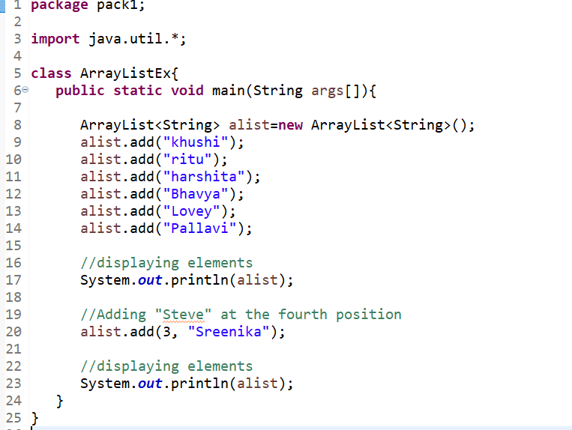

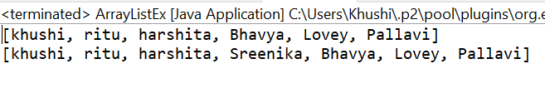

2. Create a LinkedList class and apply different methods for that class size(),contains(),isEmpty(),getFisrt(). print the results.

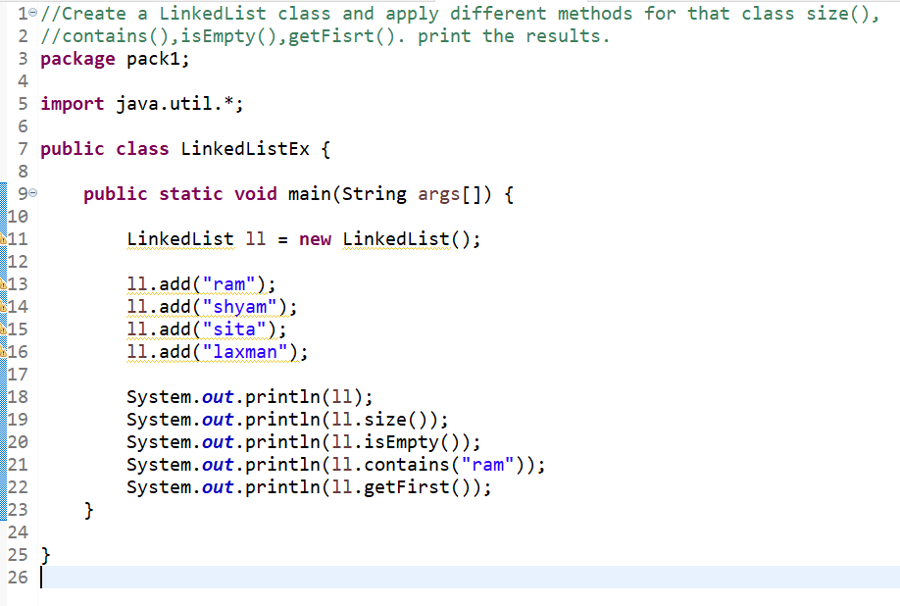

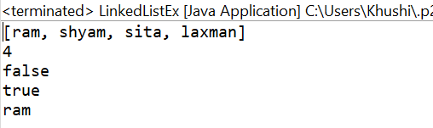

3.  Create a class with generics(particular type integer) and add the values print even numbers.

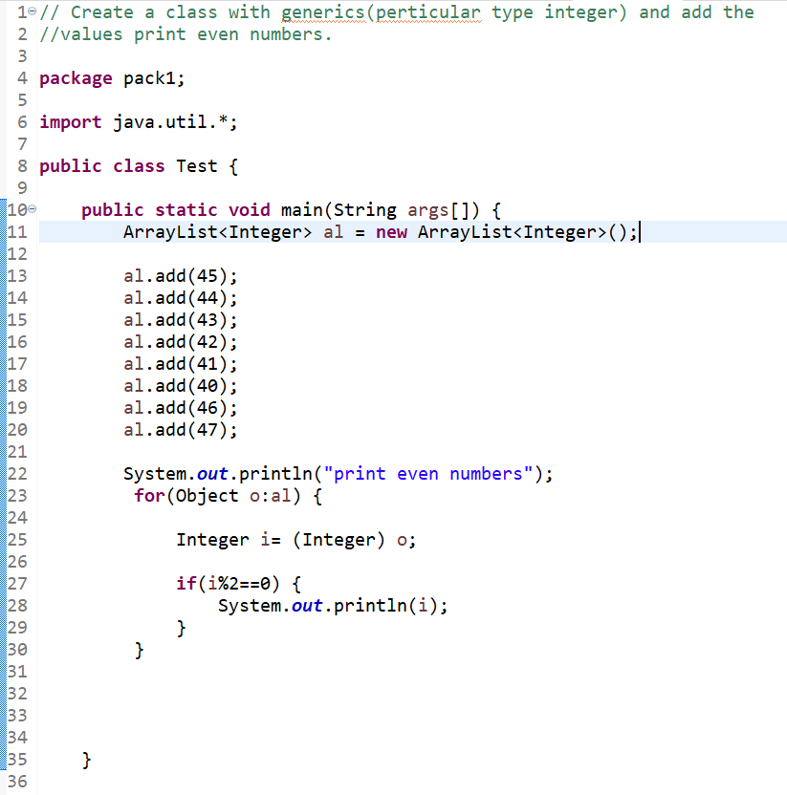

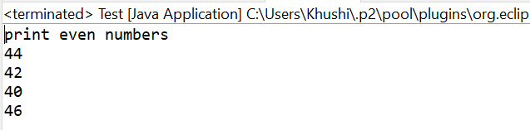

4.  class name is test and taking arraylist object add different objects and print the values by using for loop and foreach loop.

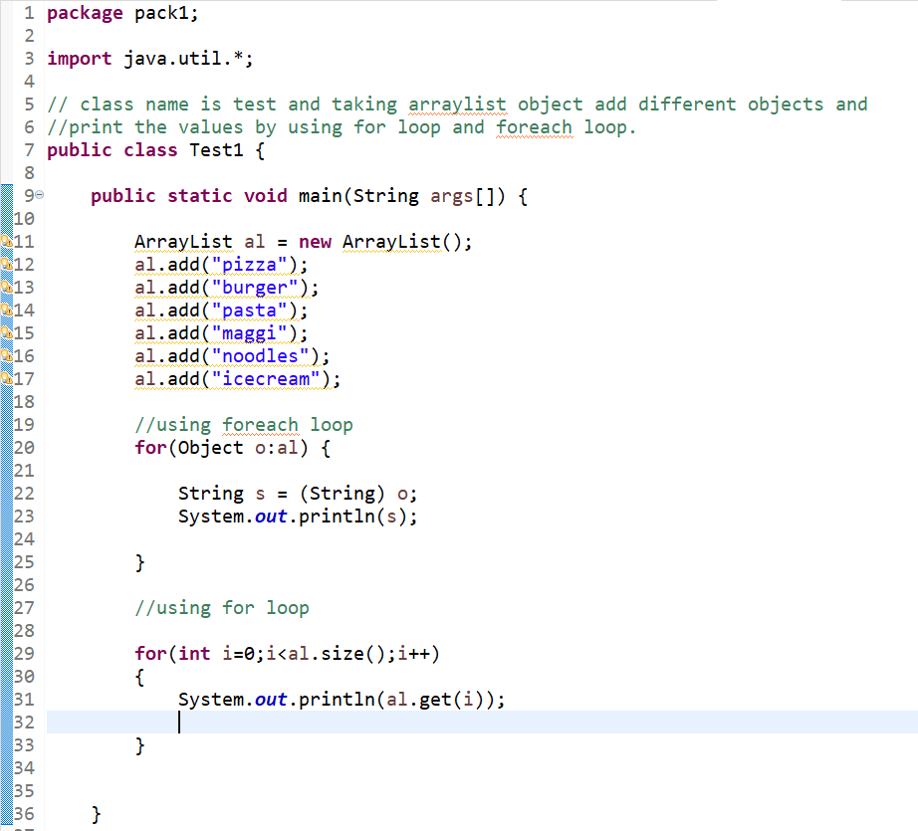

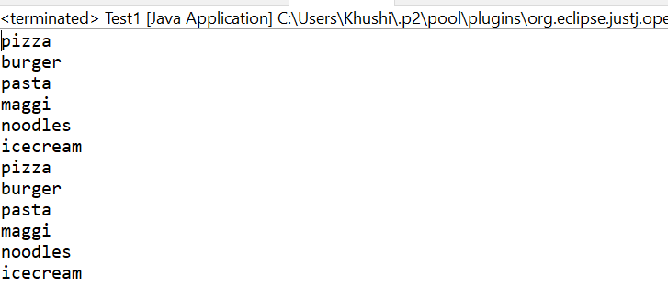

5. Create a of Linked List add the heterogenous objects print all the objects.

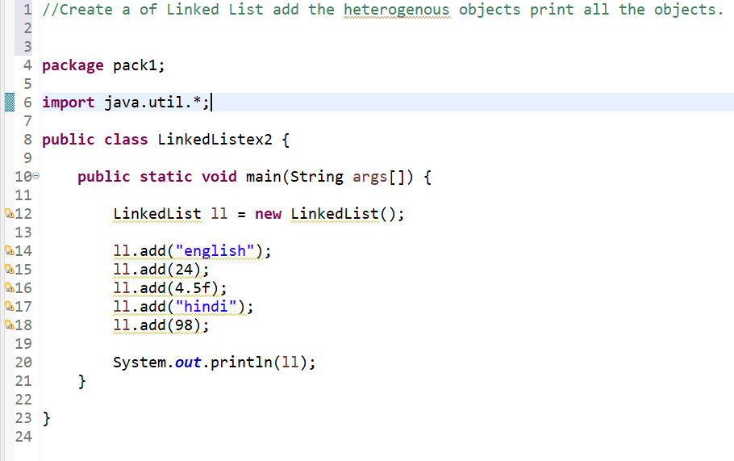

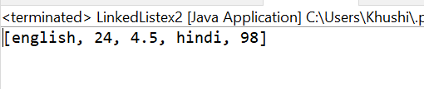

**SESSION 2**

**1.** Create a priorityQueue class add elements and print the values.

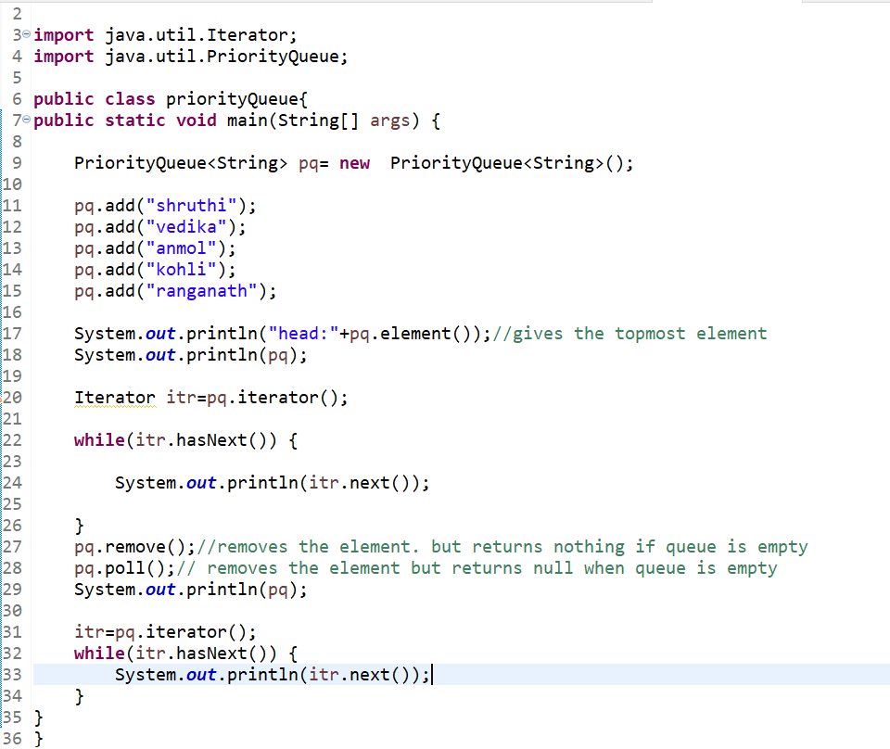

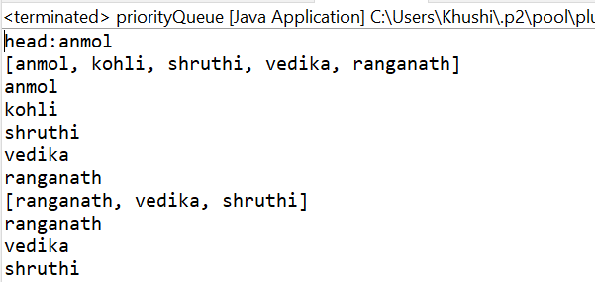

2. Create a of HasSet add the heterogenous objects print all the objects.

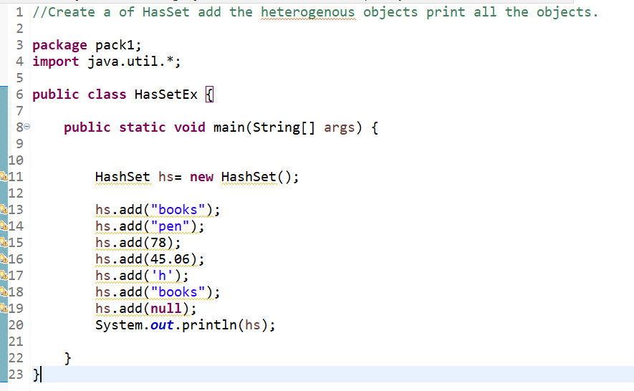

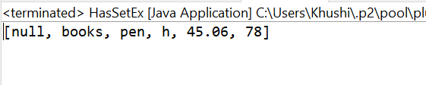

3. Create a of Linked HashSet add the heterogenous objects print all the objects.

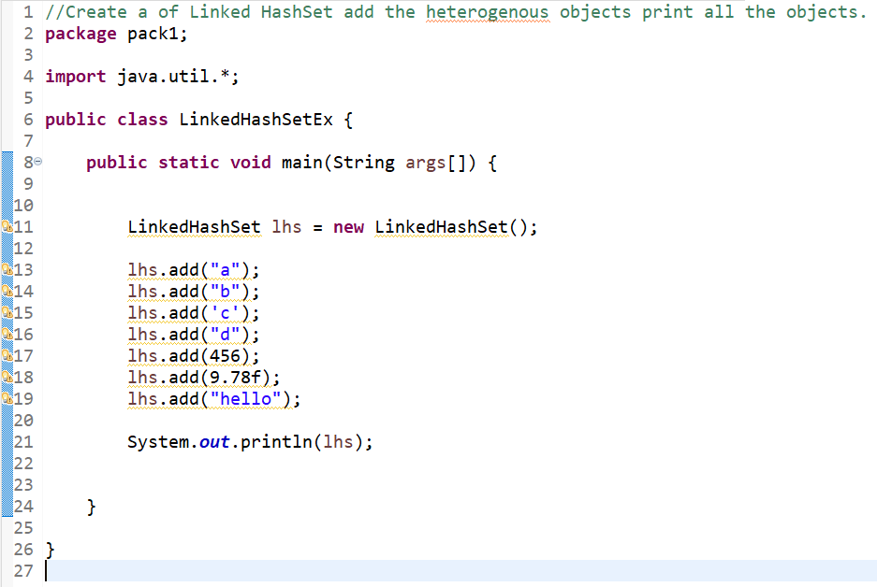

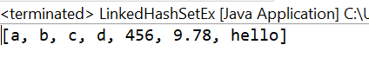

4. By using Generics create Tree Set and print the all the values.

